ENERGY FLOW

The ecosystem is composed of animate and inanimate components that are related to each other. The ecosystem feeds and renews itself through the element and energy cycles among these components. There is a constant trading between air, water, soil, pants and other organisms through the element cycle and the energy circulation. This trade enables the reusability and the recyclability of the natural means and the sustainability of life.

Food Chain

All living organisms on earth need energy for their survival. All types of material (water, oxygen, nitrogen, etc.) that are required for nutrient production are present on earth. However, in order for the organisms to be able to use these materials, they need to be converted into organic nutrients (carbohydrates, proteins, lipids). Plants, algae and some bacteria are organisms that are able to convert inorganic matter into organic nutrients via photosynthesis (Figure 1). The solar energy is required for this conversion to take place.

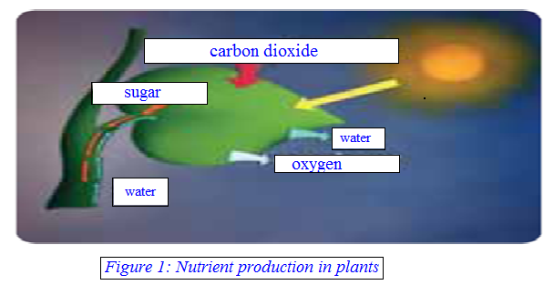

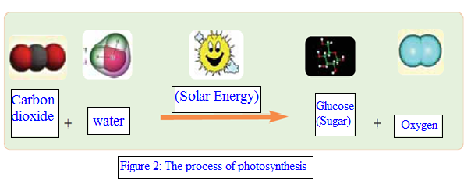

Let’s see how the plants perform nutrient production through the investigation of Figures 1 and 2. Plants produce glucose and oxygen through the use of the solar energy utilizing carbon dioxide and water. The energy from the sun is stored in the nutrients that the photosynthetic organisms produce. When the nutrients are consumed by the organism, this energy is transferred to the organisms. Energy is thus transferred through nutrition from one organism to the other.

The energy stored in the form of nutrients in plants is distributed to all organisms in a manner likely for a food chain. Let’s investigate the components of the food chain that is shown in the figure below (Figure 3).

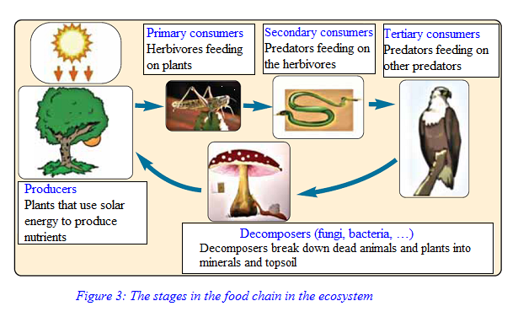

Each link in the food chain where energy is transferred from one group to another is a nutritional level. A large portion of the energy that has been transferred along the food chain is used for the survival requirements of that organism while the rest is transferred to the next link in the chain. This energy transfer in the food chain can be modeled into a pyramid (Figure 4).

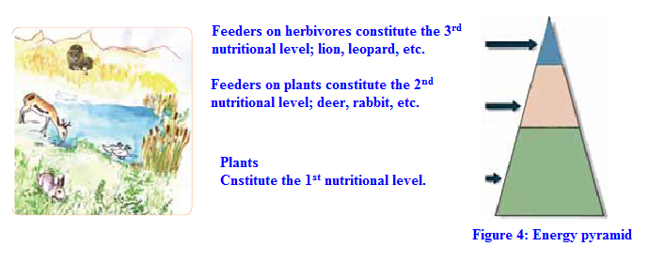

Energy Flow

All organisms require energy to maintain their vital activities. An alternating, unidirectional energy flow is present in the ecosystem which arrives from the sun moving towards the producers, herbivore consumers, predator consumers and decomposers, changing in every organism. A partial amount of the energy that has been consumed by the organisms is dispersed in the form of heat. The energy flow takes place as shown in Figure 5:
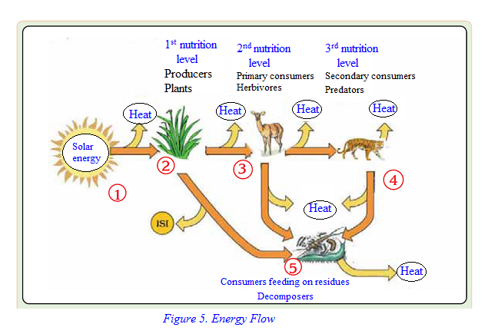

We may conclude the following by investigating the figure:
- Sun is the sole source of energy for the ecosystems.
- A significant portion of the solar energy arriving on earth is held by the producers and as previously explained, they are converted into chemical energy via photosynthesis.
- Herbivores use the energy that they acquire from the plants to maintain their vital activities.
- Predators hunt herbivores and uptake the energy stored in the herbivore body. They use this energy for their vital activities.
- An important part of the energy is used by the decomposers in the ecosystems. For instance, from the plants in a meadow, only 10% of the energy is taken up by the grazing animals and the rest by the decomposers.

