**MITOCHONDRION**

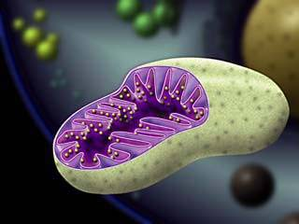

Mitochondrion is the source of energy for the living organism. The oxygen is burnt by the agency of the structures in the mitochondrion and energy is obtained as a result of this. This process is called respiration. Since O2 is used during the process, the special name given to it is aerobic respiration.

The structural constituents of the mitochondrion, named as the matrix and the christae take role in respiration.