**ECOSYSTEM**

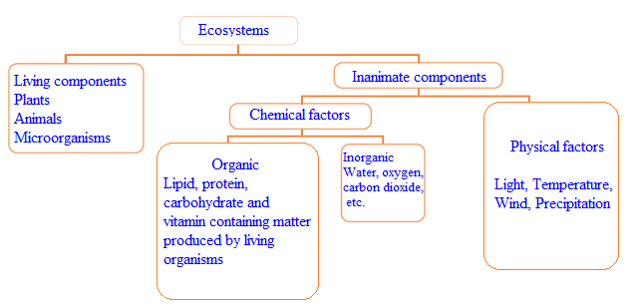

Living organisms are in constant interaction with the hydrosphere, atmosphere and the lithosphere. Ecosystem encloses the living organisms and the interactions both among themselves and with their surroundings. These ecosystems may differ in size greatly from micron level areas to the biosphere. As a forest may form an ecosystem, a dead tree, a river, a pond, a mountain, a sea or even the whole planet may be regarded as an ecosystem (Figure 1).

An ecosystem is a dynamic unit since its quality, structure and the various roles that the member elements play may continuously evolve in time. The Atmosphere, hydrosphere, lithosphere and the biosphere constitute the earth ecosystem, or in other words the ecosystem. The ecosphere can be divided into three major ecosystems, namely the land, the sea water and the fresh water. Many smaller ecosystems exist within these large ecosystems.



*Figure 1: The largest ecosystem, the ecosphere*